**1950s Venetian Scalloped Gilt Mirror**

**Price: $4000**

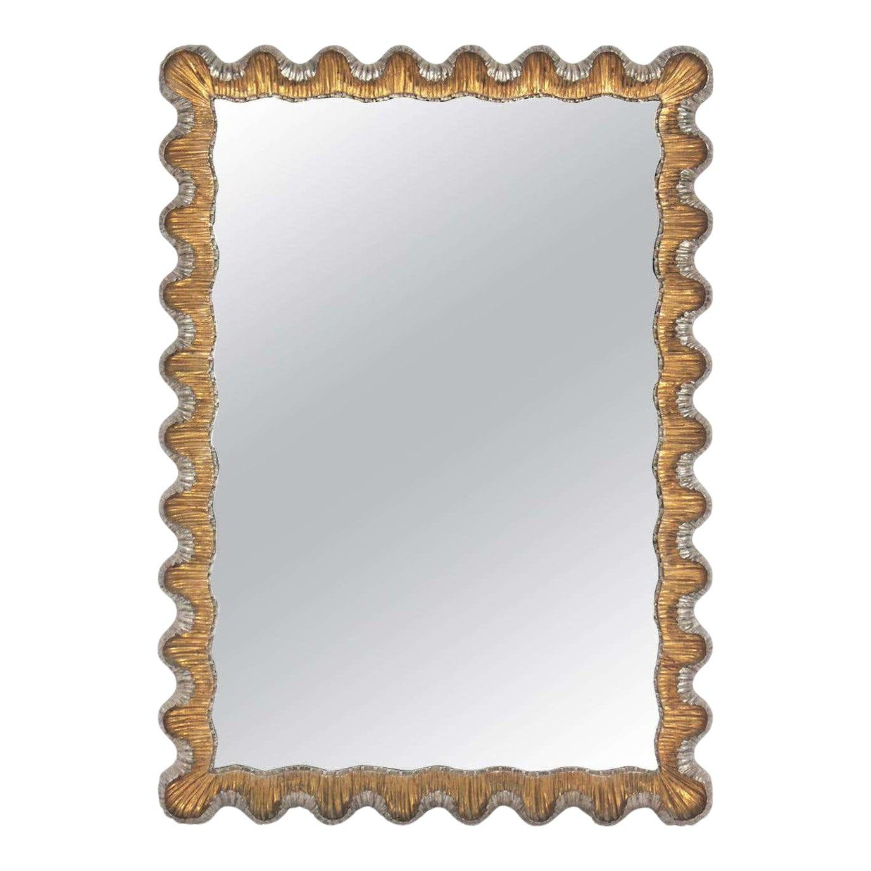

* CATEGORIES

Bathroom mirrors

* MATERIALS

Metal Bordered

* SHAPE

Rectangle

* BRAND

Viglacera